PRACTICAL NO: 03
Title: Creating an Application in SalesForce.com using Apex programming Language.

STEPS TO CREATE AN APPLICATION :

Step No 1: Create new org:
https://developer.salesforce.com/signup

Signup Page:
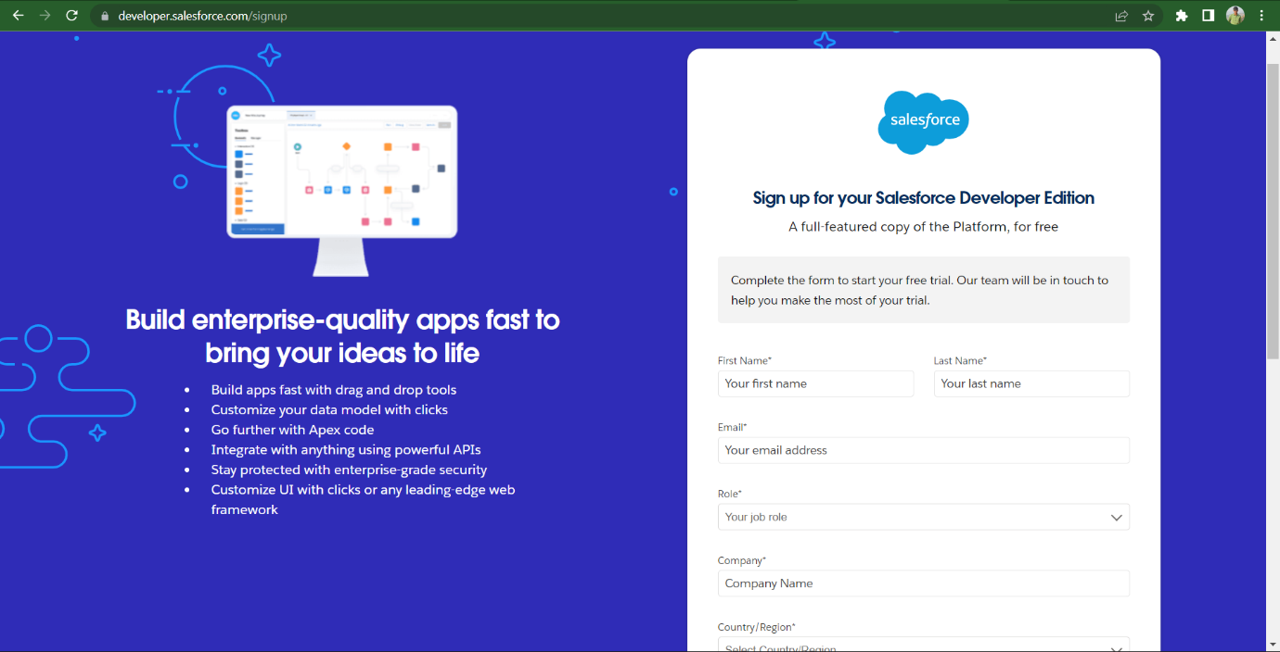

Step No 2: After signup, loging using following URL
https://login.salesforce.com/

Step No 3: Login Page (Enter your credential to login)
Login Page:-
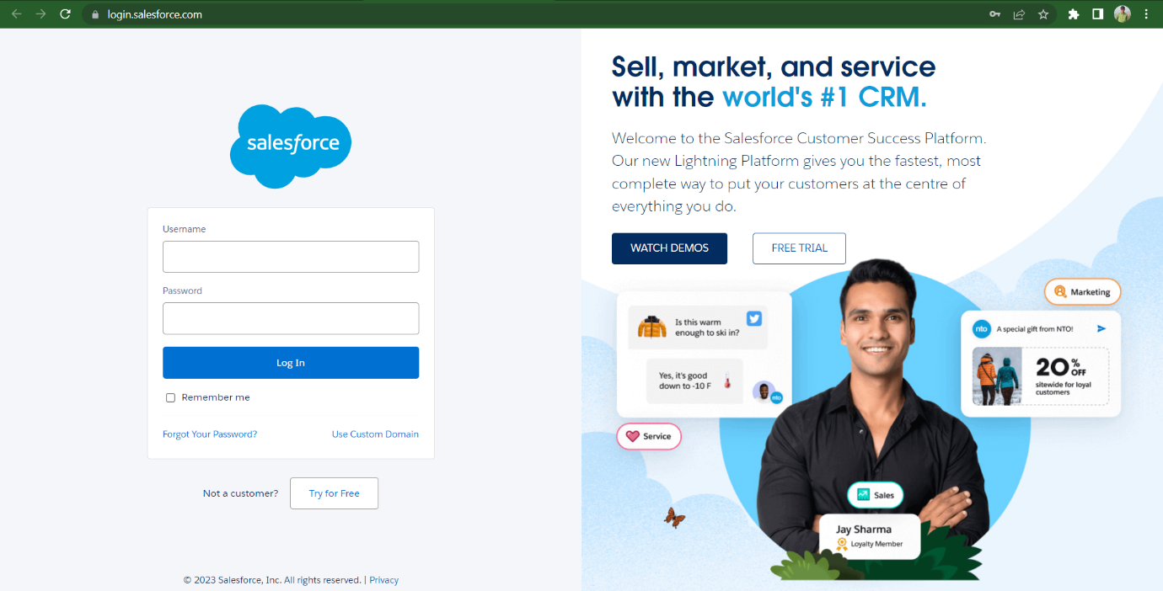

Home Page:-
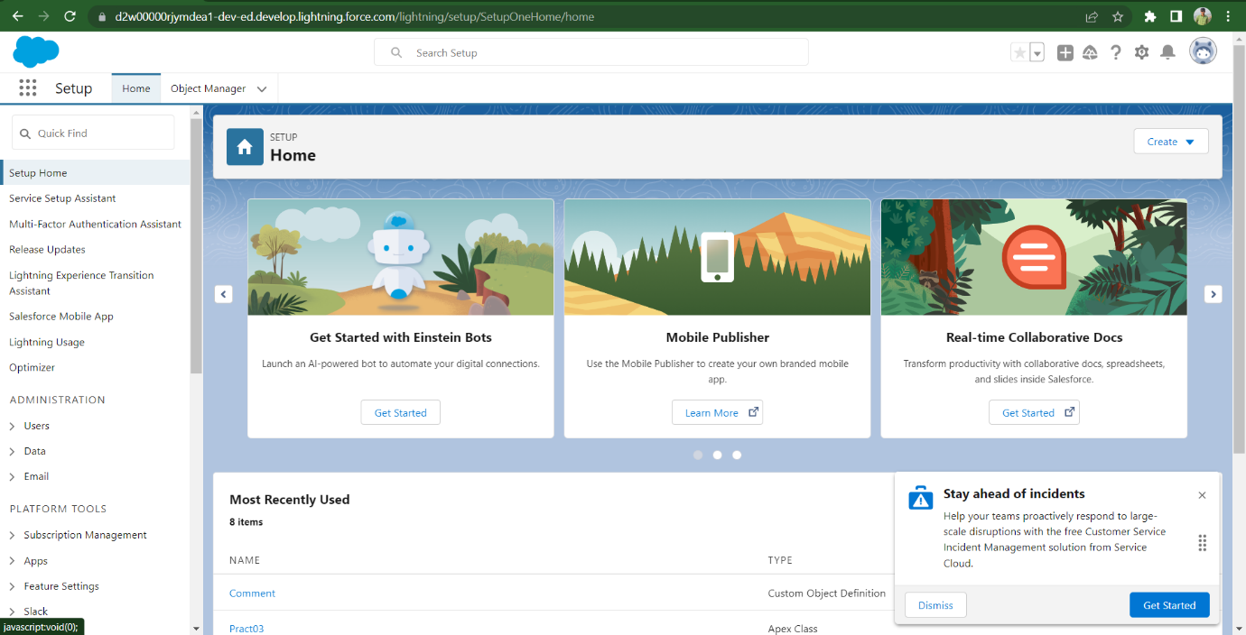

1. Open Developer Console

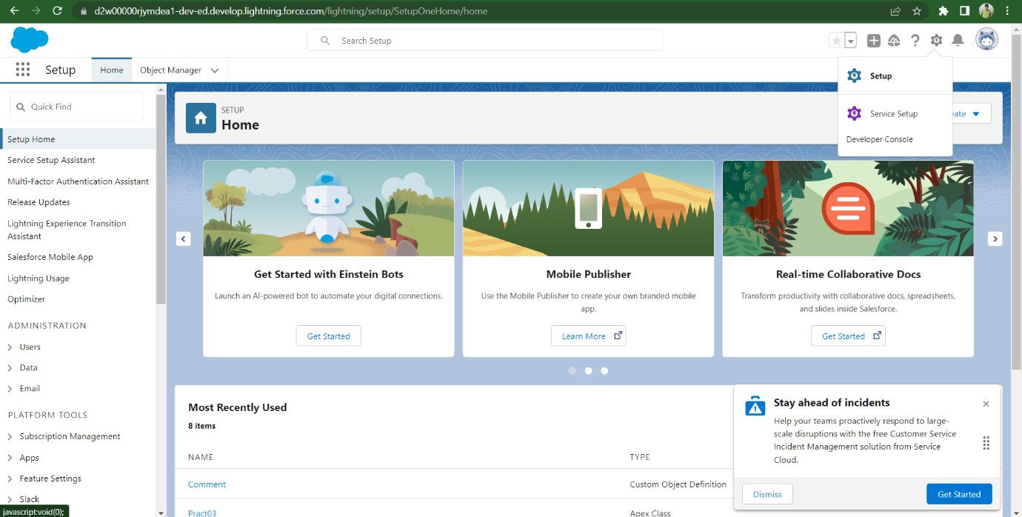

2. File ---> New ---> Select Apex Class
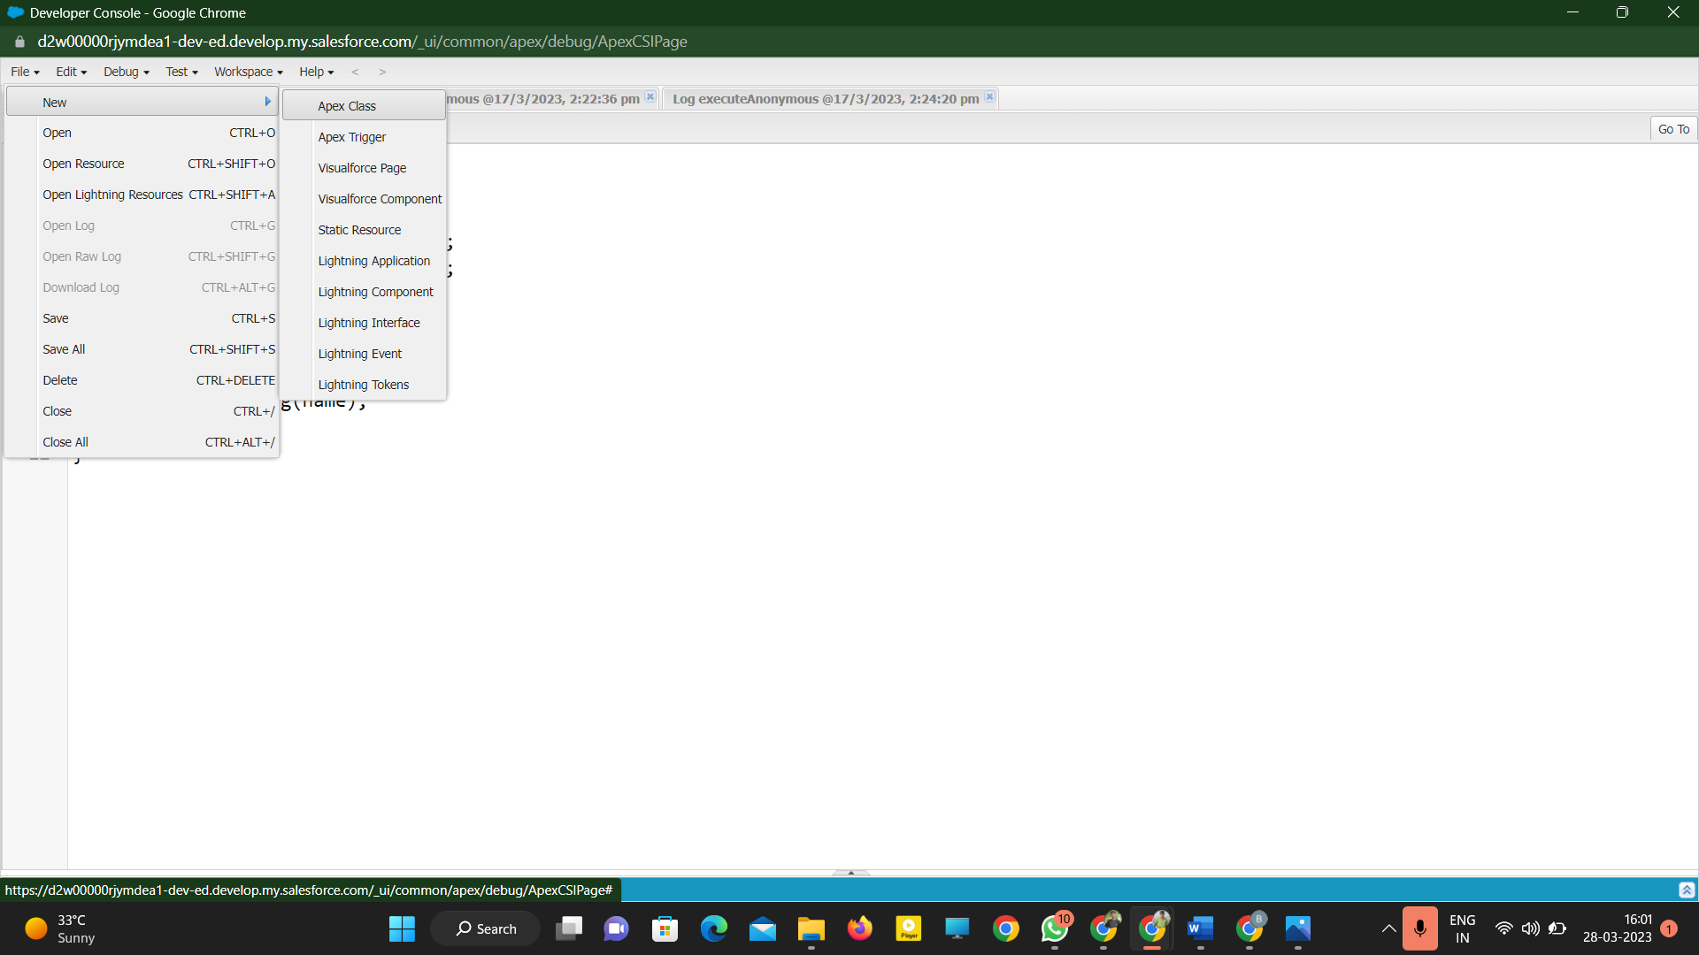
3. Give Name for Apex Class:
4. Type below mentioned code
public class Demo
{
public static void Demo1()
{
System.debug('WELCOME TO METIOE NASHIK');
}
}

Note : you can write any code as application
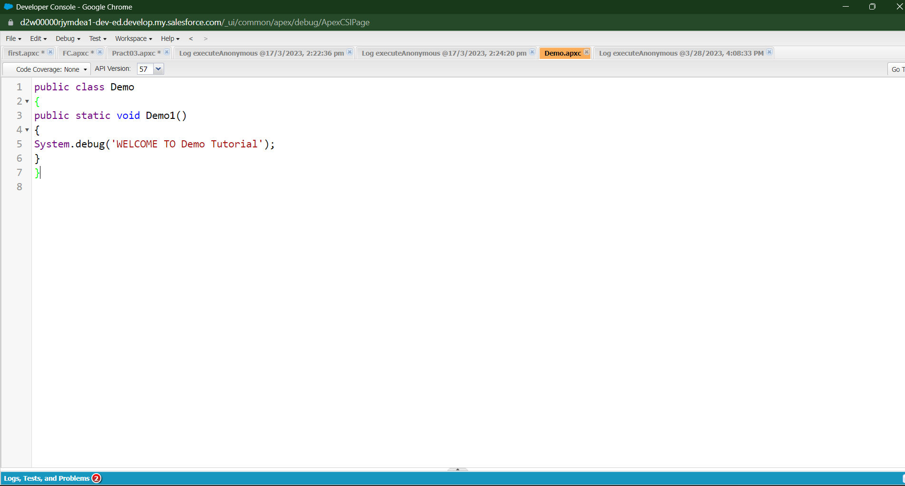
5. Click on Debug ---> Open Execute Acronymous Window
6. Type below code(Apex Code)
Demo.Demo1();
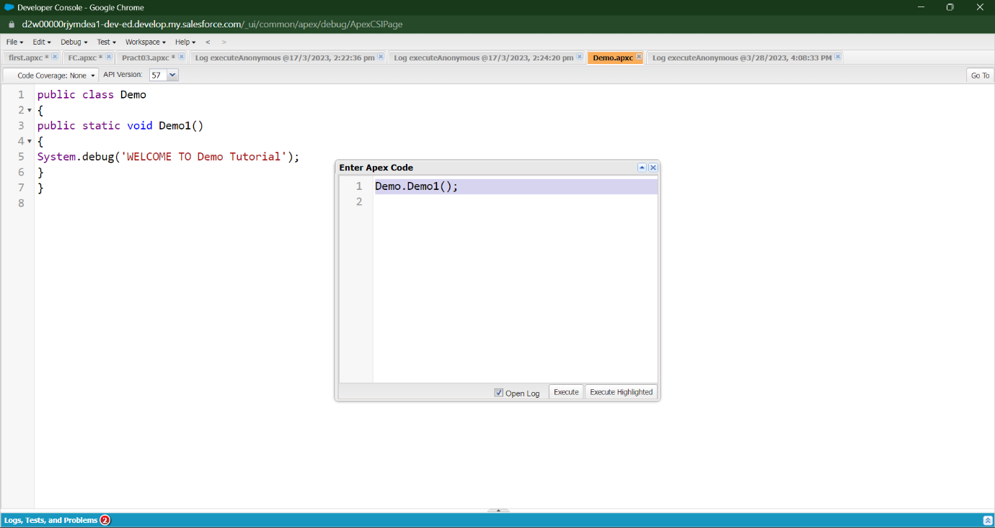
7. Click on Open log then Execute code
8. Click on Debug only (You will get output)
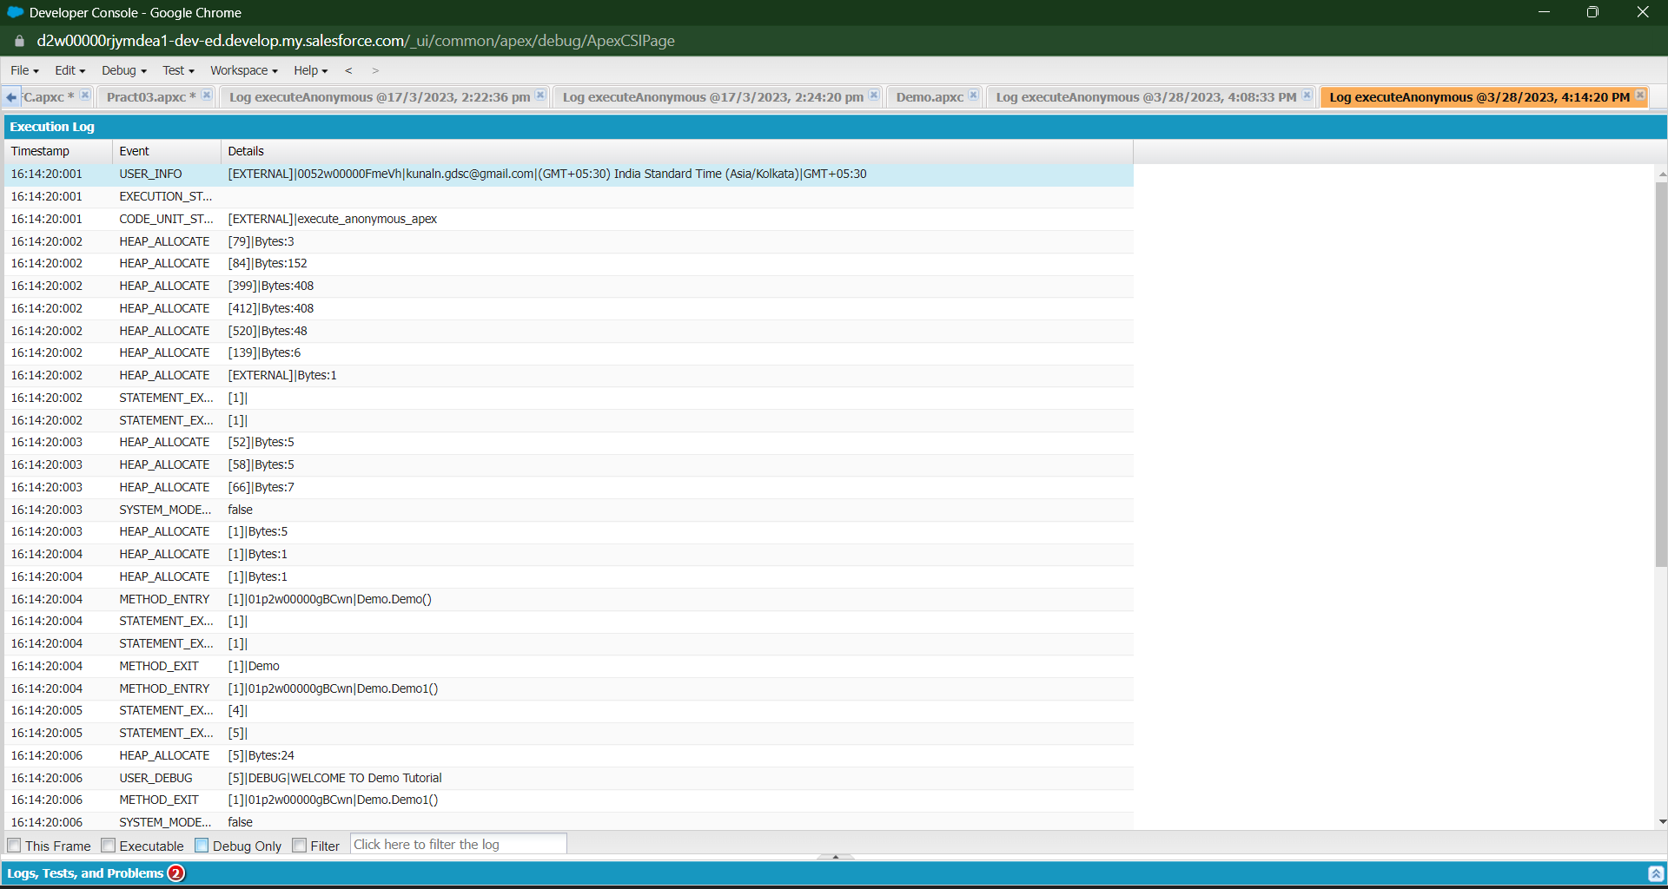
OUTPUT:
